Lunch Menu

Week 1
 | Monday | Tuesday | Wednesday | Thursday | Friday
Meat choice | Spaghetti bolognaise  Corn on the cob | Chicken nuggets and chips with peas and carrots | Cheese and tomato pizza  Potato wedges  Greek salad | Bizeli with chicken and rice (green pea stew)  Greek Salad | Mini fish and chips with baked beans
Vegetarian choice | Spaghetti with cheese and tomato  Corn on the cob | Vegetable nuggets and chips with Greek salad | Cheese and tomato pizza  Potato wedges  Greek salad | Jacket potatoes (cheese/sweet corn/tuna/beans and salad) | Mac and cheese
Dessert | Chocolate cake | Yoghurt, granola and fruit compote | Fruit salad | Carrot cake with icing | Rice crispy cakes

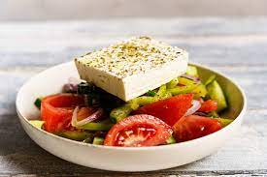
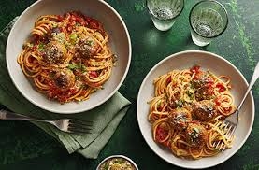

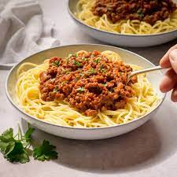

Week 2
 | Monday | Tuesday | Wednesday | Thursday | Friday
Meat choice | Chicken curry with rice  Nan bread | Grilled chicken with mashed potato and beans | Pizza and chips with beans | Meat burger with sweet potato wedges, sweetcorn | Mini fish fingers and chips with beans
Vegetarian choice | Jacket potatoes (cheese/sweet corn/tuna/beans and salad) | Fasolaki and Bulgar wheat (Green beans and potatoes in tomato sauce) | Vegetarian pizza – cheese, tomato and olives  Greek salad | Vegetable burger with sweet potato wedges, sweetcorn | Mac and cheese
Dessert | Rice crispy cakes | Apple and oat cupcakes | Fruit salad | Jelly (no added sugar) | Yoghurt, granola and fruit compote
Week 3
 | Monday | Tuesday | Wednesday | Thursday | Friday
Meat choice | Chicken wrap with chips and salad | Jacket potato (tuna/sweetcorn/salad/beans/cheese) | Macaronia dou fournou with meat (macaroni in oven)  Potato salad with parsley – no mayonnaise | Chicken escalope with mash potato and beans | Mini fish and chips with beans
Vegetarian choice | Halloumi wrap with chips and salad | Filo pastry parcel with spinach and feta with Greek salad | Vegetarian macaronia dou fournou (Macaroni in oven)  Potato salad with parsley – no mayonnaise | Veggie fingers with mash potato and beans | Mac and cheese
Dessert | Banana cake | Fruit salad | Yoghurt, granola with fruit compote | Blueberry muffins | Cornflake cakes

